It's been some year. Starting since in April I was in Hershey Med eight times. In May I had surgery on my lower abdomen during which three surgeons removed various bits and pieces of the remains of a few selected organs which had gone on strike. I managed, despite dire predictions, to live through the eight hour procedure and recovered rather quickly, despite more dire predictions. My digestion and various other aspects of my civil engineering have been altered and I now have two ostomies named Ralph (colostomy) and Rover (urostomy).
I was unaware of the seriousness of the procedure although my family had been told to expect the worse worst. There I was, lying on the gurney and joking with the several dozens of blue-clad members of the audience, and turned my head to say to the nearest human, “While you're at it change the wipers and do a lube and oil.” The anesthesiologist (<--I changed the spelling) shut me up before I spoke, and I woke up hours later telling folks I felt fine and was ready to go home – which I did, nine days later.
I am back docenting at the Cornwall Iron Furnace. I do it every other Saturday.
Vicki continues in good health, and really has been my nurse, my disciplinarian, and my memory, “Did you take your noon time pills and your fly is open again.” She is also my best friend and constant companion.
We keep busy just maintaining our property and cutting, splitting and stacking firewood because we heat in part with wood. We also are much involved with Cavi and family as they live across the lane.
Cavi works for a tree and lawn service based in Harrisburg. She is third in command and is in charge of HR, accounting and safety. In her copious free time she answers phone calls and interviews the 60+workers and spends long hours doing it. She is on several boards, the Furnace, Domestic Violence Intervention, and Conservancy.
Karline is 14, a freshman and very much involved in theater and the high school chorus. Elliot is 12, in the sixth grade and is rather tall for his age. Every few days he likes to measure his height to keep a close eye on the need for new clothes. He plays the trumpet and is in the school band and the jazz band.
Michael lives in Millis, MA, and is the site supervisor for enormous building projects. He works for Hanover Co. which builds apartment buildings. They are very fancy with marble countertops, marble lobbies, marble furniture, marble pools, and marble tenants.
Livy is 15 and a sophomore at the local vo-tech high school “majoring” in culinary arts. She also has a part-time job in an elder care facility.
Each Both? of our children has a love interest and we are very fond of both. They each have been mentors and willing ears for the kids' inevitable stresses.
Attached Below is a page of recent pictures of all of us. Let me know if you can't open the file.

Love to all,
Pat and Vicki
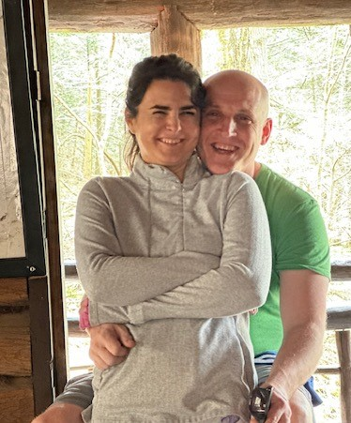
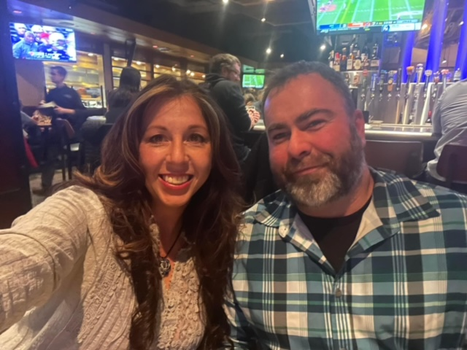

Sheri and Michael
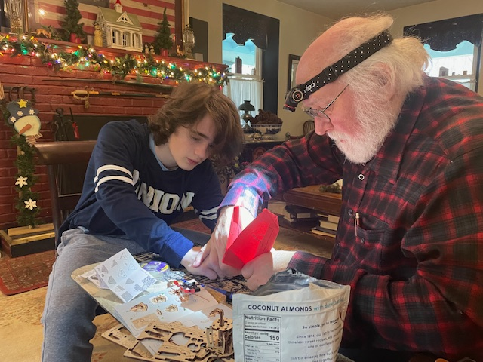
Sheri and Michael
Cavi and Todd
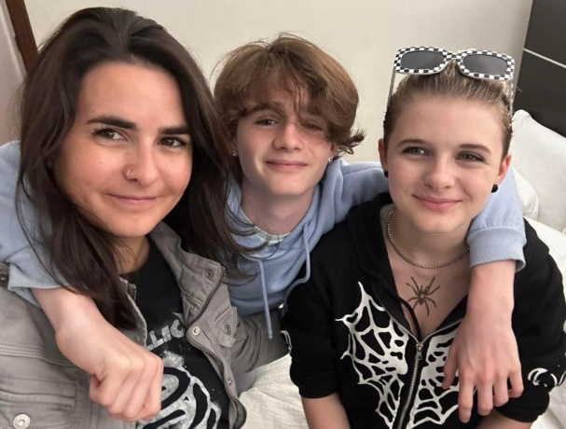
Cavi and Todd
Uncle Mike and Elliot at work
Cavi Elliot and Karline
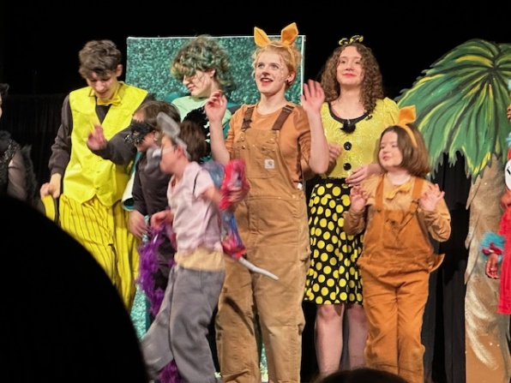
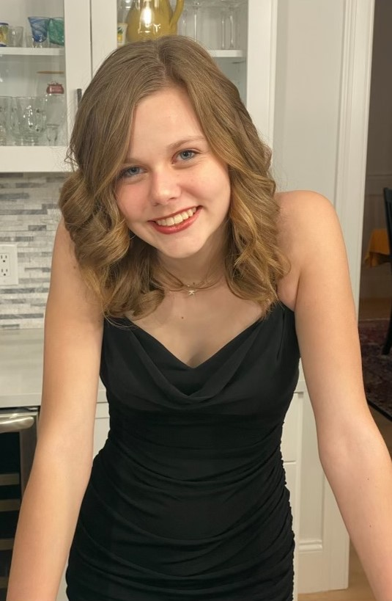

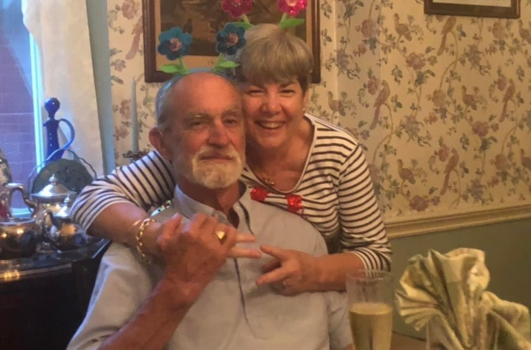
Karline in Seussical
Livy dressed for Homecoming Us, or should I say “We”?

